**SalePoint Documentation**

**UML Class Diagram**

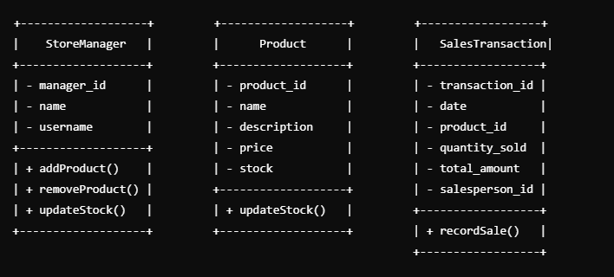

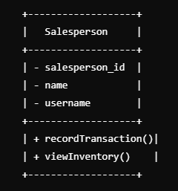

**Key Components**

**1. StoreManager Class**

* **Attributes**:
  + manager_id: Unique identifier for the store manager.
  + name: Store manager's name.
  + username: Username for login or identification.
* **Methods**:
  + addProduct(): Add new products to inventory.
  + removeProduct(): Remove products from inventory.
  + updateStock(): Update the stock level of a product.

**2. Salesperson Class**

* **Attributes**:
  + salesperson_id: Unique identifier for the salesperson.
  + name: Salesperson's name.
  + username: Username for login or identification.
* **Methods**:
  + recordTransaction(): Record a new sales transaction.
  + viewInventory(): View current inventory (read-only).

**3. Product Class**

* **Attributes**:
  + product_id: Unique identifier for the product.
  + name: Name of the product.
  + description: Description or details about the product.
  + price: Selling price of the product.
  + stock: Current stock level of the product.
* **Methods**:
  + updateStock(): Adjust stock quantity (called by the manager).

**4. SalesTransaction Class**

* **Attributes**:
  + transaction_id: Unique identifier for each transaction.
  + date: Date and time of the transaction.
  + product_id: Identifier for the product being sold.
  + quantity_sold: Quantity sold in this transaction.
  + total_amount: Calculated total for the transaction (quantity × price).
  + salesperson_id: Identifier for the salesperson responsible for the sale.
* **Methods**:
  + recordSale(): Records the transaction details.

**Use Case Diagram**

1. **Actors**:
   * **Store Manager**: Responsible for managing inventory (add/remove/update products).
   * **Salesperson**: Responsible for recording sales transactions and viewing stock levels.

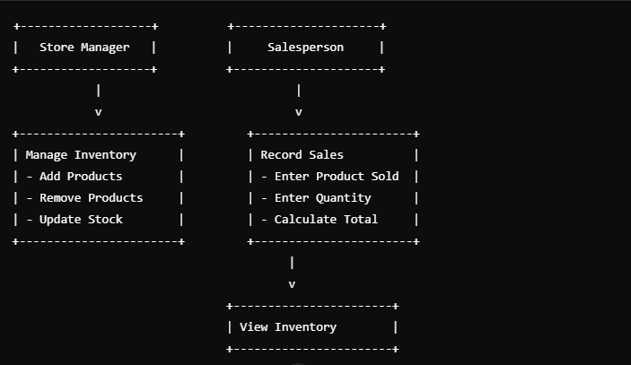



**Example Workflow**

**1. Store Manager's Workflow:**

* Logs in as a **manager**.
* Adds products to the inventory:
  + Example: Adds 50 units of "Soap" at $1.5 each.
* Updates stock for existing products:
  + Example: Updates "Soap" stock to 100 units.
* Removes discontinued products:
  + Example: Removes "Old Product A."

**2. Salesperson's Workflow:**

* Logs in as a **salesperson**.
* Views inventory to check product availability:
  + Example: Sees "Soap" has 100 units in stock.
* Records a sale:
  + Example: Sells 5 units of "Soap" for a total of $7.5.
* Transaction is logged in the system:
  + Product stock is updated to 95 units.

This UML diagram and explanation should align with your requirements. Let me know if you'd like further refinements or an actual implementation example!